### NUMERICAL COMPUTING

### BS COMPUTER

### SCIENCE

5TH

SEMESTER

### CHAPTER NO 01

**ERRORS**

# SIGNIFICANT DIGITS

A significant digit of an approximate number is any non-zero digit in its decimal representation, or any zero lying between significant digits, or used as place holder to indicate a retained place. The digits 1, 2, 3, 4, 5, 6, 7, 8, 9 are significant digits. ‘0’ is also a significant figure except when it is used to fix the decimal point, or to fill the places of unknown or discarded digits.

**For example**, in the number 0.0005010, the first four ‘0’s’ are not significant digits, since they serve only to fix the position of the decimal point and indicate the place values of the other digits. The other two ‘0’s’ are significant.

Two notational conventions which make clear how many digits of a given number are significant are given below.

**1.** The significant figure in a number in positional notation consists of:

**(a)** All non-zero digits and

**(b)** Zero digits

**(i)** Which lie between significant digits

**(ii)** which lie to the right of decimal point, and at the same time to the right of a non-zero digit

**(iii)** are specifically indicated to be significant

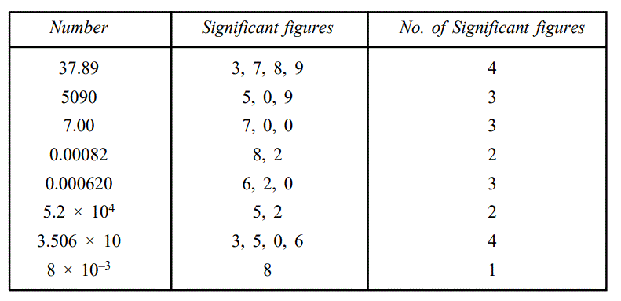 **2**. The significant figure in a number written in scientific notation (M × 10n) consists of all the digits explicitly in M. Significant figures are counted from left to right starting with the left most non zero digit.

**EXAMPLE # 01**

# ROUNDING OFF NUMBERS

Sometimes it may be necessary to cut the numbers with large numbers of digits**. This process of cutting the numbers is called rounding off numbers. In rounding off a number after a computation, the number is chosen which has the required number of significant figures and which is closest to the number to be rounded off.** Usually numbers are rounded off according to the following rule.

Rounding-off rule: In order to round-off a number to n significant digits drop all the digits to the right of the nth significant digit or replace them by ‘0’s’ if the ‘0’s’ are needed as place holders, and if this discarded digit is 1. Less than 5, leave the remaining digits unchanged 2. Greater than 5, add 1 to the last retained digit 3. Exactly 5 and there are non-zero digits among those discarded, add unity to the last retained digit.

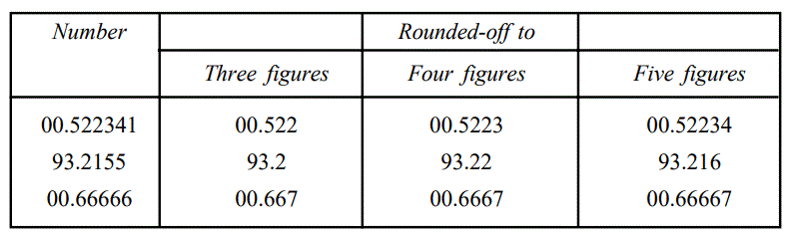**EXAMPLE # 01**

**EXAMPLE # 02**

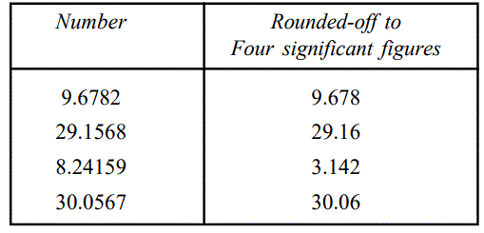

ERRORS

**One of the most important aspects of numerical analysis is the error analysis. Errors may occur at any stage of the process of solving a problem. By the error we mean the difference between the true value and the approximate value**.

**∴ Error = True value – Approximate value**

Types of Errors

**Usually we come across the following types of errors in numerical analysis.**

Inherent Errors. These are the errors involved in the statement of a problem. When a problem is first presented to the numerical analyst it may contain certain data or parameters. If the data or parameters are in some way determined by physical measurement, they will probably differ from the exact values. Errors inherent in the statement of the problem are called inherent errors.

Analytic Errors. These are the errors introduced due to transforming a physical or mathematical problem into a computational problem. Once a problem has been carefully stated, it is time to begin the analysis of the problem which involves certain simplifying assumptions. The functions involved in mathematical formulas are frequently specified in the form of infinite sequences or series.

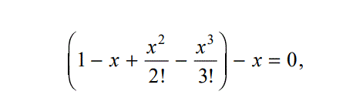**For example,**

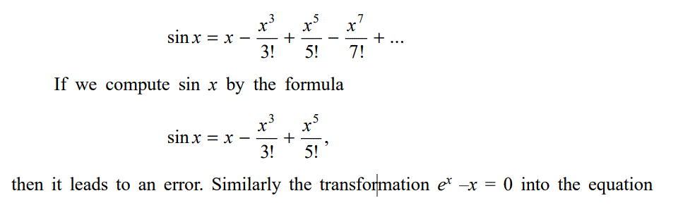

involves an analytical error.

Round-off errors. When depicting even rational numbers in decimal system or some other positional system, there may be an infinity of digits to the right of the decimal point, and it may not be possible for us to use an infinity of digits, in a computational problem. Therefore it is obvious that we can only use a finite number of digits in our computations. This is the source of the so called rounding errors. Each of the FORTRAN Operations +, –, *, /, **, is subject to possible round off error.

By the error of an approximate number we mean the difference between the exact number X, and the given approximate number x. It is denoted by

**E (or by ∆) E = ∆ = X -- x**

**An exact number may be regarded as an approximate number with error zero.**

The absolute error of an approximate number x is the absolute value of the difference between the corresponding exact number X and the number x. It is denoted by EA.

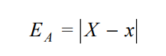

The limiting error of an approximate number denoted by ∆x is any number not less than the absolute error of that number.

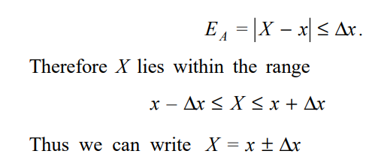

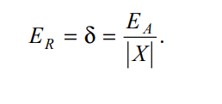The relative error of an approximate number x is the ratio of the absolute error of the number to the absolute value of the corresponding exact number X, where X ≠ 0 . It is denoted by ER (or by δ).

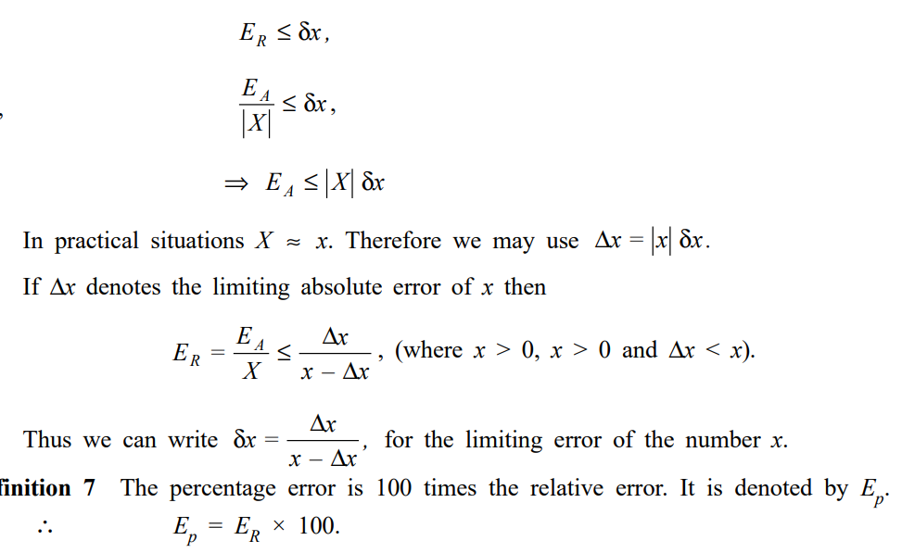The limiting relative error δx of a given approximate number x, is any number not less than the relative error of that number.

**Example 1.6** Round-off 27.8793 correct to four significant figures**.**

**Solution** The number 27.8793 rounded-off to four significant figures is 27.88.

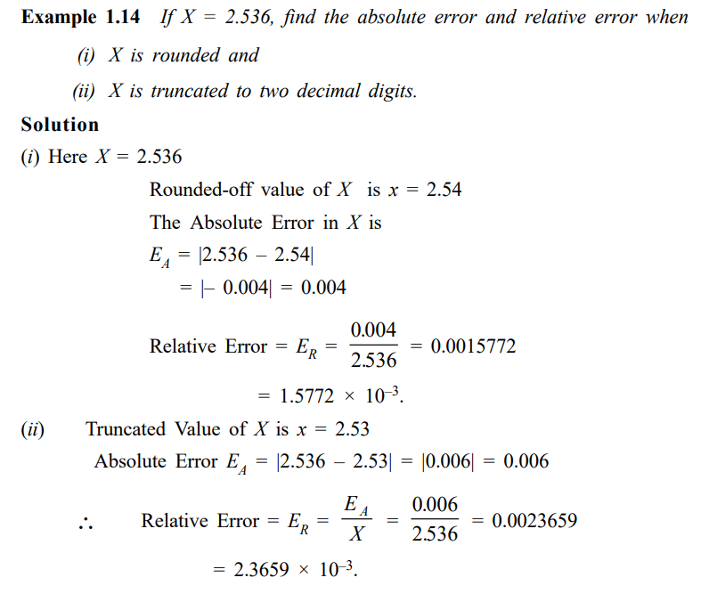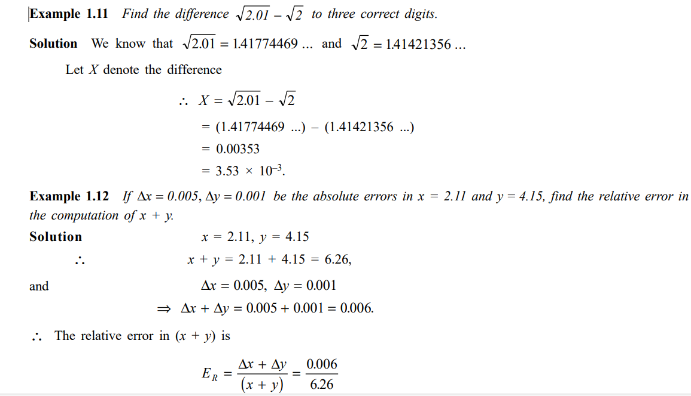The relative error in (x + y) = 0.001 (approximately).